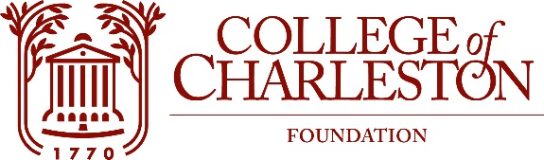
INVESTMENT COMMITTEE MEETING
Stern Center Ballroom, 71 George Street
November 16, 2023
10:45 a.m.

MISSION
The Mission of the College of Charleston Foundation is to promote programs of education, research, student development, and faculty development for the exclusive benefit of the College of Charleston.

Committee Members:
Mark J. Buono ‘81, Chair Keith Sauls ‘90, Vice-Chair
Tina Cundari ‘96 Bartina Edwards ‘87
Jamilla Harper Sabra Horne ‘87
Noah Leask Mitsy Mangum ‘86
Justin McLain ‘98 Brady Quirk-Garvan ‘08

Board Chair: Steve Kerrigan
Executive Director: Dan Frezza
Staff: J.R. Barnhart and Leah Barron
Guests: TIFF - Willie Zantzinger and Jim Russo

Agenda:

- Call to Order & Welcome

- Approval of Minutes

- Investment Report – tiff

- Q & A

