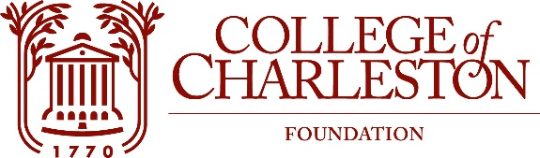
PROPERTY COMMITTEE MEETING
THURSDAY, OCTOBER 28 2021
VIA ZOOM
11:00 – 12:00 am

The Mission of the College of Charleston Foundation is to promote programs of education, research, student development, and faculty development for the exclusive benefit of the College of Charleston.
Committee Members:
Chappy McKay, Chair Craig Eney
Rallis Papas, Vice Chair Robbie Freeman
Mark Buono Gus Gustafson
John Carter Amy Heyel
Tina Cundari Tricia Ory

Liaison: Barney Holt
Executive director: Cathy Mahon
Ex Officios: Debye Alderman

Agenda:

- Call to Order; FOIA; Welcome

- Approval of minutes

- New Business

- Executive Session ( if required )

- Other Business

- Adjournment

