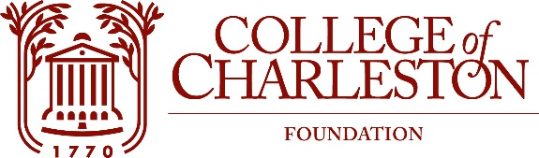
INVESTMENT COMMITTEE MEETING
May 12, 2021
Zoom Meeting
4:00 P.M.

MISSION
The Mission of the College of Charleston Foundation is to promote programs of education, research, student development, and faculty development for the exclusive benefit of the College of Charleston.

Committee Members:
Mark J. Buono ‘81, Vice Chair Scott Cracraft ‘83
Steve Kerrigan Noah Leask
Justin McLain ‘98, Chair Keith Sauls ‘90

Board Chair: Peggy Boykin ‘81
Executive Director: Chris Tobin
Staff: Debye Alderman, Leah Barron
Guests: TIFF - Willie Zantzinger and Anuja Navaratna

Agenda:

- Call to Order & Welcome

- Approval of Minutes

- Investment Report – TIFF

- Q & A

- Adjournment

