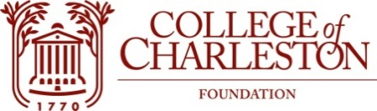

EXECUTIVE COMMITTEE MEETING
august 22, 2019
alumni center
School of education, health and human performance
8:00-8:30 AM

The Mission of the College of Charleston Foundation is to promote programs of education, research, student development, and faculty development for the exclusive benefit of
the College of Charleston

Committee Members:
Jeff Kinard ’77, Chair Peggy Boykin ‘81, Vice-Chair
Glen Brown’76 Amy Heyel ‘92
Steve Kerrigan Chappy McKay ‘86
Justin McLain ‘98 Keith Sauls ’90
Hilton Smith Eric Cox ’93
Tomi Youngblood Sherrie Snipes-Williams
Vic Howie ‘83 Fleetwood Hassell
Tina Cundari ‘96 Neil Draisin ‘65
Laura Ricciardelli

LIAISONS:
Chris Tobin Barney Holt ’74
J. R. Barnhart Leah Barron
Laurie Soenen Hanna Spencer
Debye Alderman Carin Jorgensen
Cathy Mahon ’80 Marijana Boone ’01, ’03

AGENDA:

I. CALL TO ORDER

II. WELCOME & QUORUM

III. FOIA STATEMENT

IV. MOTION: MINUTES OF 5-16-19

V. BOARD CHAIR REMARKS

VI. COMMITTEE REPORTS

VII. OLD BUSINESS

VIII. NEW BUSINESS

IX. EXECUTIVE SESSION

X. ADJOURN

